Lab Objective

Creating Windows Deployment Images

**Lab Procedures**

**1.** On Server01, create theC:\Software folder.

**2.** On Server01, right-click the Start button, select Run and type \\RWDC01\Software, then click OK.

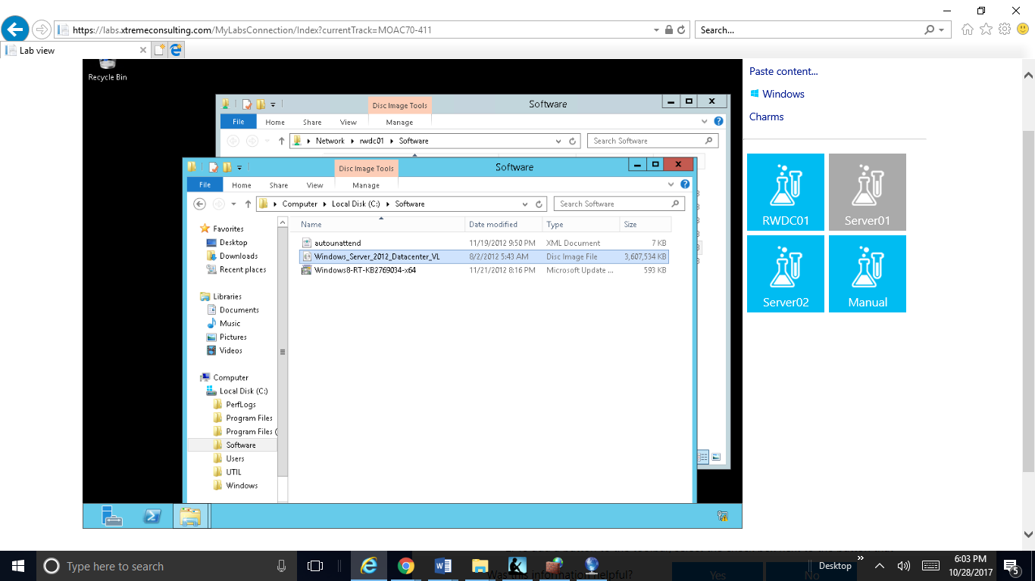**3.** Copy the ISO file for the Windows Server 2012 installation disk, the autounattend.xml file and the Windows8-RT-KB2769034-x64.msu file to the C:\Softwarefolder as shown below.

Figure 1. Copy the ISO file for the Windows Server 2012 installation disk, the autounattend.xml file and the Windows8-RT-KB2769034-x64.msu file to the C:\Software folder

**4.** On Server01, open the C:\Softwarefolder.

**5.** Right-click the ISO file for Windows Server 2012 installation disk and select Mount.

**6.** From the Windows Deployment Services console, expand Servers, and expand Server01.contoso.com, so that you can see the Install Images folder and the Boot Images folders.

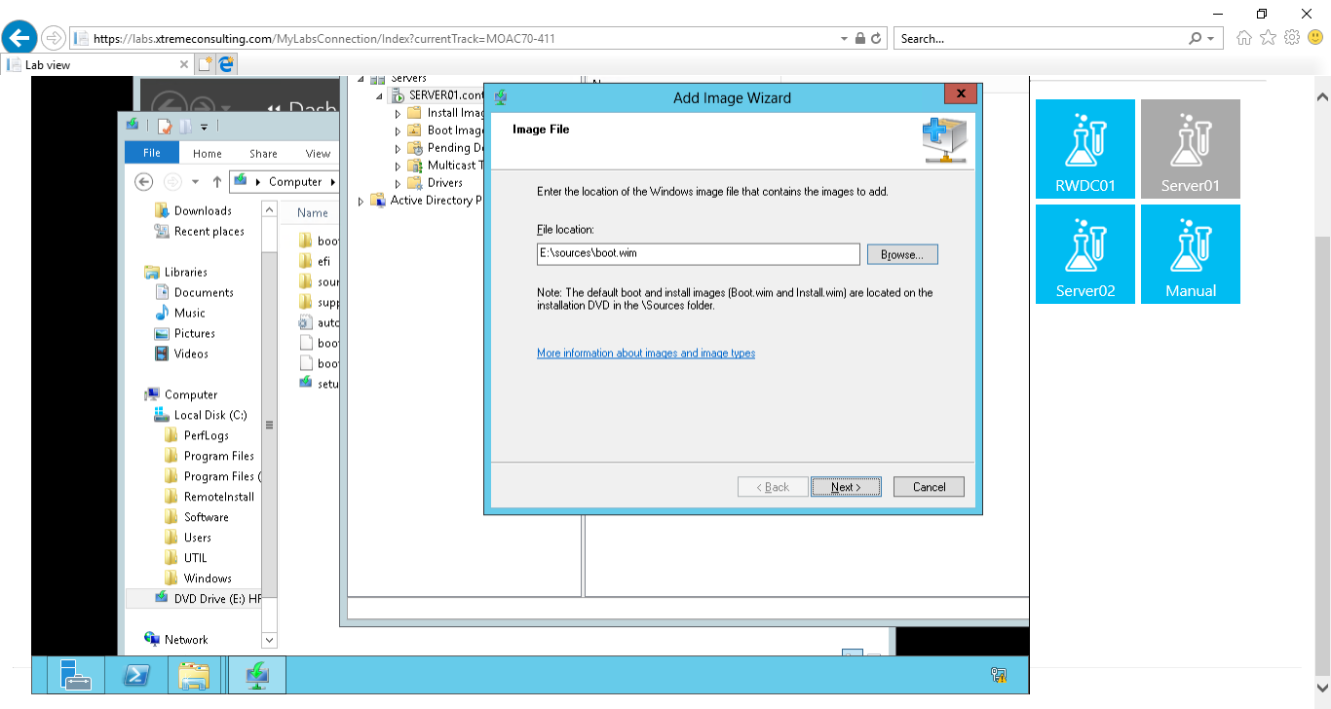**7.** To add a boot image, right-click the Boot Images folder and choose Add Boot Image. The Add Image Wizard opens.

Figure 2: Step 7. Add Image Wizard opens

**8.** Browse to the E:\Sources folder, and click the boot.wim file, and then click Open. Click Next.

**9.** On the Image Metadata page, click Next.

**10.** On the Summary page, click Next.

**11.** When the image is added to the server, click Finish.

**12.** Right-click the Install Images folder and select Add Install Image. The Add Image Wizard page opens.

**13.** On the Image Group page, the Create an image group named option is selected. Click Next.

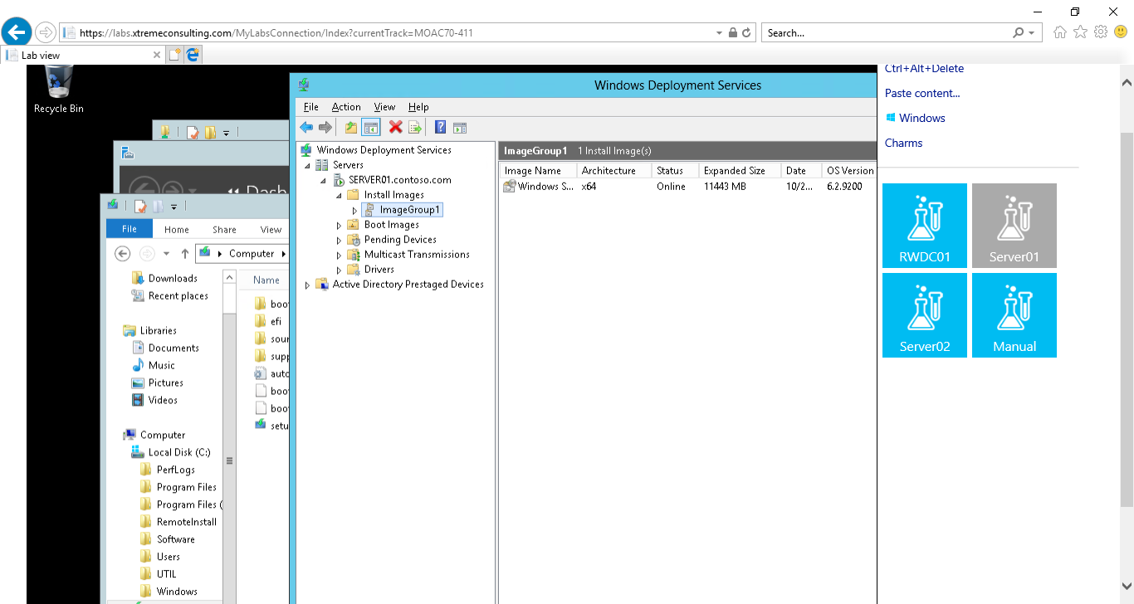**14.** Browse to the E:\Sources folder and double-click install.wim file, and then click Next.

Figure 3 Step 14 Browse to the E:\Sources folder and double-click install.wim file, and then click Next

**15.** On the Available Images page (as shown on Figure 1-1), deselect the following images:

* Windows Server 2012 SERVERSTANDARDCORE
* Windows Server 2012 SERVERDATACENTERCORE
* Windows Server 2012 SERVERDATACENTER

Be sure that Windows Sever 2012 SERVERSTANDARD is selected. Click Next.

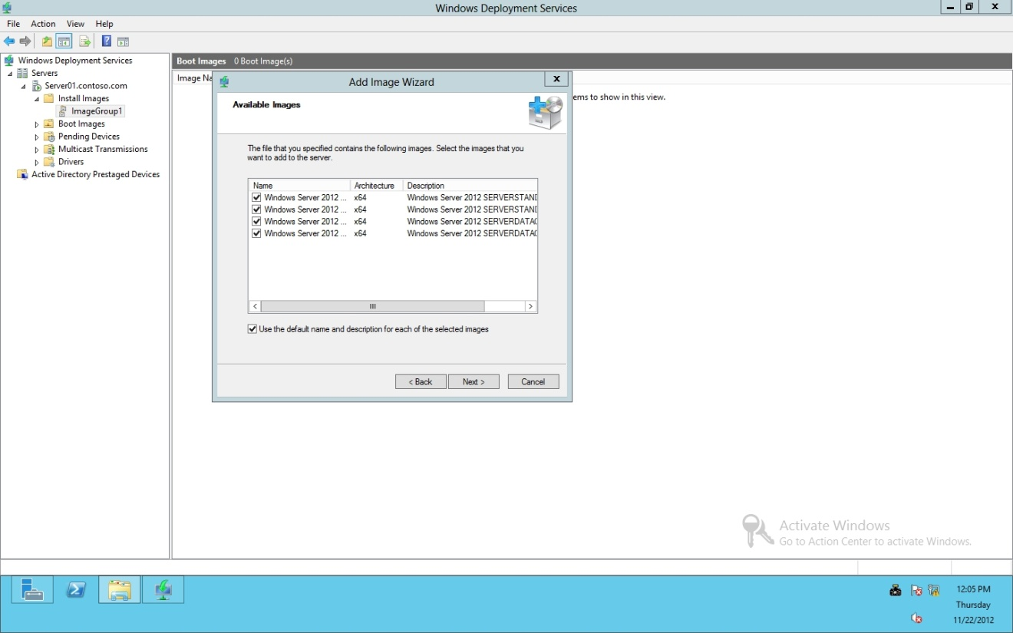

Figure 1-1

Selecting images to use

**16.** On the Summary page, click Next.

**17.** When the imageis added to the server, click Finish.

**Lab Review Questions**

What drive letter was the ISO file mounted to?

E drive

What is the boot image based on?

.iso file

In Exercise 1.2, what two images did you have to add to the WDS server to handle the Windows installation?

Boot.wim & install.wim

**Lab Summary**

In this exercise, I learned how to lanuch MOAC70-411-Lab01 Deploying and Managing Server Images; prepared images (boot images and install images) that will be used to deploy Windows.